Chapter 17. Going Live

In the previous chapter, you built a real-time chat server for students using Django Channels. Now that you have created a fully functional e-learning platform, you need to set up a production environment so that it can be accessed over the internet. Until now, you have been working in a development environment, using the Django development server to run your site. In this chapter, you will learn how to set up a production environment that is able to serve your Django project in a secure and efficient manner.

This chapter will cover the following topics:

- Configuring Django settings for multiple environments

- Using Docker Compose to run multiple services

- Setting up a web server with uWSGI and Django

- Serving PostgreSQL and Redis with Docker Compose

- Using the Django system check framework

- Serving NGINX with Docker
- Serving static assets through NGINX

- Securing connections through Transport Layer Security (TLS) / Secure Sockets Layer (SSL)

- Using the Daphne Asynchronous Server Gateway Interface (ASGI) server for Django Channels

- Creating a custom Django middleware

- Implementing custom Django management commands

In previous chapters, diagrams at the start represented views, templates, and end-to-end functionalities. This chapter, however, shifts focus to setting up a production environment. Instead, you will find specific diagrams to illustrate the environment setup throughout the chapter.

The source code for this chapter can be found at
https://github.com/PacktPublishing/Django-5-byexample/tree/main/Chapter17.

All Python modules used in this chapter are included in the requirements.txt file in the source code that comes along with this chapter.

You can follow the instructions to install each Python module below or you can install all requirements at once with the python -m pip install -r requirements.txt command.

Creating a production environment
It’s time to deploy your Django project in a production environment. You will start by configuring Django settings for multiple environments, and then you will set up a production environment.

Managing settings for multiple environments
In real-world projects, you will have to deal with multiple environments. You will usually have at least a local environment for development and a production environment for serving your application. You could have other environments as well, such as testing or staging environments.

Some project settings will be common to all environments, but others will be specific to each environment. Usually, you will use a base file that defines common settings, and a settings file per environment that overrides any necessary settings and defines

additional ones.
We will manage the following environments:

- local : The local environment to run the project on your machine

- prod : The environment for deploying your project on a production server

Create a settings/ directory next to the settings.py file of the educa project. Rename the settings.py file to base.py and move it into the new settings/ directory.

Create the following additional files inside the settings/ folder so that the
new directory looks as follows:
settings/
__init__.py
base.py
local.py
prod.py

These files are as follows:

- base.py : The base settings file, which contains common settings (previously settings.py)

- local.py : Custom settings for your local environment

- prod.py : Custom settings for the production environment

You have moved the settings files to a directory one level below, so you need to update the BASE_DIR setting in the settings/base.py file to point to the main project directory.

When handling multiple environments, create a base settings file and a settings file for each environment. Environment settings files should inherit the common settings and override environment-specific settings.

Edit the settings/base.py file and replace the following line:
BASE_DIR = Path(__file__).resolve().parent.parent

Replace the preceding line with the following one:
BASE_DIR = Path(__file__).resolve().parent.parent.parent
You point to one directory above by adding .parent to the BASE_DIR path. Let’s configure the settings for the local environment.

Local environment settings
Instead of using a default configuration for the DEBUG and DATABASES settings, you will define them for each environment explicitly. These settings will be environment specific. Edit the educa/settings/local.py file and add the following lines:
from .base import *
DEBUG = True
DATABASES = {
'default': {
'ENGINE': 'django.db.backends.sqlite3',
'NAME': BASE_DIR / 'db.sqlite3',
}
}

This is the settings file for your local environment. In this file, you import all settings defined in the base.py file, and you define the DEBUG and DATABASES settings for this environment. The DEBUG and DATABASES settings remain the same as you have been using for development.

Now, remove the DATABASES and DEBUG settings from the base.py settings file.

Django management commands won’t automatically detect the settings file to use because the project settings file is not the default settings.py file. When running management commands, you need to indicate the settings module that you want to use by adding a --settings option, as follows:
python manage.py runserver --settings=educa.settings.local

Next, we are going to validate the project and the local environment configuration.

Running the local environment
Let’s run the local environment using the new settings structure. Make sure Redis is running or start the Redis Docker container in a shell with the following command:
docker run -it --rm --name redis -p 6379:6379 redis:7.2.4

Run the following management command in another shell, from the project directory:
python manage.py runserver --settings=educa.settings.local

Open http://127.0.0.1:8000/ in your browser and check that the site loads correctly. You are now serving your site using the settings for the local environment.
If don’t want to pass the --settings option every time you run a management command, you can define the DJANGO_SETTINGS_MODULE environment variable. Django will use it to identify the settings module to use. If you are using Linux or macOS, you can define the environment variable by executing the following command in the shell:
export DJANGO_SETTINGS_MODULE=educa.settings.local

If you are using Windows, you can execute the following command in the shell:
set DJANGO_SETTINGS_MODULE=educa.settings.local

Any management command you execute after this will use the settings defined in the DJANGO_SETTINGS_MODULE environment variable.

Stop the Django development server from the shell by pressing the Ctrl + C keys and stop the Redis Docker container from the shell by also pressing the Ctrl + C keys.

The local environment works well. Let’s prepare the settings for the production environment.

Production environment settings
Let’s start by adding initial settings for the production environment. Edit the educa/settings/prod.py file and make it look as follows:
from .base import *
DEBUG = False
ADMINS = [
('Antonio M', 'email@mydomain.com'),
]
ALLOWED_HOSTS = ['*']
DATABASES = {
'default': {
'ENGINE': 'django.db.backends.sqlite3',
NAME: BASE_DIR / 'db.sqlite3',
}
}

These are the settings for the production environment:

- DEBUG : Setting DEBUG to False is necessary for any production environment. Failing to do so will result in the traceback information and sensitive configuration data being exposed to everyone.

- ADMINS : When DEBUG is False and a view raises an exception, all information will be sent by email to the people listed in the ADMINS setting. Make sure that you replace the name/email tuple with your own information.
- ALLOWED_HOSTS : For security reasons, Django will only allow the hosts included in this list to serve the project. For now, you allow all hosts by using the asterisk symbol, * . You will limit the hosts that can be used for serving the project later.

- DATABASES : You keep the default database settings pointing to the SQLite database of your local environment. You will configure the production database later.

Over the next sections of this chapter, you will complete the settings file for your production environment.

You have successfully organized settings for handling multiple environments. Now, you will build a complete production environment by setting up different services with Docker.

Using Docker Compose
You initially used Docker in Chapter 3, Extending Your Blog Application, and you have been using Docker throughout this book to run containers for different services, such as PostgreSQL, Redis, and RabbitMQ.

Each Docker container combines application source code with operating system libraries and dependencies required to run the application. By using application containers, you can improve your application portability. For the production environment, we will use Docker Compose to build and run multiple Docker containers.

Docker Compose is a tool for defining and running multi-container applications. You can create a configuration file to define the different services and use a single command to start all services from your configuration. You can find information about Docker Compose at https://docs.docker.com/compose/.

For the production environment, you will create a distributed application that runs across multiple Docker containers. Each Docker container will run a different service. You will initially define the following three services and you will add additional services in the next sections:

- Web service: A web server to serve the Django project

- Database service: A database service to run PostgreSQL

- Cache service: A service to run Redis

Let’s start by installing Docker Compose.

Installing Docker Compose via Docker Desktop
You can run Docker Compose on macOS, 64-bit Linux, and Windows. The fastest way to install Docker Compose is by installing Docker Desktop. The installation includes Docker Engine, the command-line interface, and Docker Compose.

Install Docker Desktop by following the instructions at
https://docs.docker.com/compose/install/composedesktop/.

Open the Docker Desktop application and click on Containers. It will look as follows:
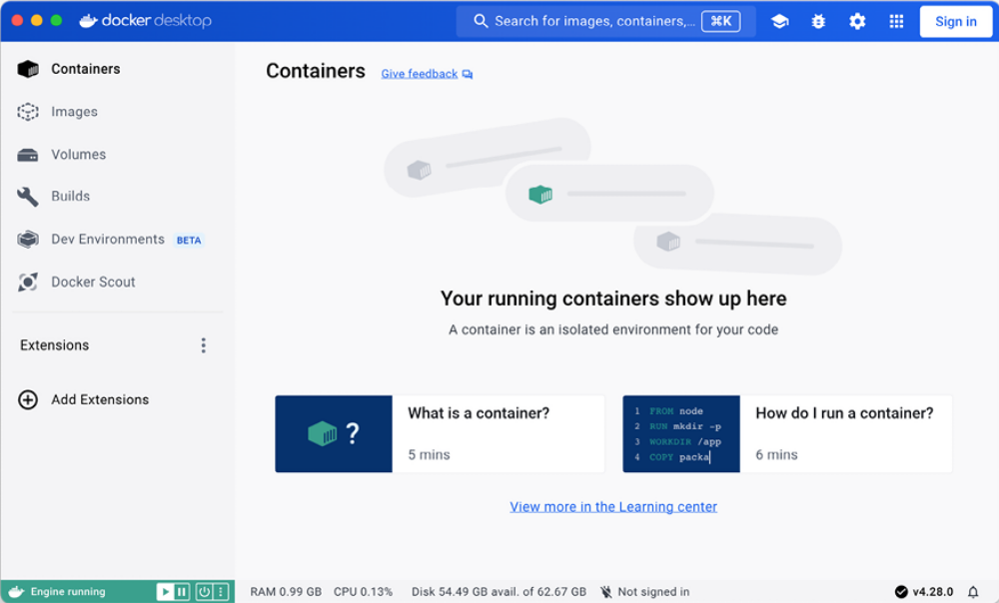
Figure 17.1: The Docker Desktop interface

After installing Docker Compose, you need to create a Docker image for your Django project.

Creating a Dockerfile
You need to create a Docker image to run the Django project. A Dockerfile is a text file that contains the commands for Docker to assemble a Docker image. You will prepare a Dockerfile with the commands for building the Docker image for the Django project.

Next to the educa project directory, create a new file and name it Dockerfile . Add the following code to the new file:
# Pull official base Python Docker image
FROM python:3.12.3
# Set environment variables
ENV PYTHONDONTWRITEBYTECODE=1
ENV PYTHONUNBUFFERED=1
# Set work directory
WORKDIR /code
# Install dependencies
RUN pip install --upgrade pip
COPY requirements.txt .
RUN pip install -r requirements.txt
# Copy the Django project
COPY . .

This code performs the following tasks:

1. The Python 3.12.3 parent Docker image is used. You can find the
official Python Docker image at https://hub.docker.com/_/python.

2. The following environment variables are set:

a. PYTHONDONTWRITEBYTECODE : This prevents Python from writing out pyc files.

b. PYTHONUNBUFFERED : This ensures that the Python stdout and stderr streams are sent straight to the terminal without first being buffered.

3. The WORKDIR command is used to define the working directory of the image.

4. The pip package of the image is upgraded.

5. The requirements.txt file is copied to the working directory (. ) of the parent Python image.

6. The Python packages in requirements.txt are installed in the image using pip .

7. The Django project source code is copied from the local directory to the working directory (. ) directory of the image.

With this Dockerfile , you have defined how the Docker image that will serve Django will be assembled. You can find the Dockerfile reference at https://docs.docker.com/reference/dockerfile/.

Adding the Python requirements
A requirements.txt file is used in the Dockerfile you created to install all of the necessary Python packages for the project.

Next to the educa project directory, create a new file and name it requirements.txt . You may have already created this file before and copied the content for the requirements.txt file from
https://github.com/PacktPublishing/Django-5-byexample/ blob/main/Chapter17/requirements.txt. If you haven’t done so, add the following lines to the newly created
requirements.txt file:
asgiref==3.8.1
Django~=5.0.4
Pillow==10.3.0
sqlparse==0.5.0
django-braces==1.15.0
django-embed-video==1.4.9
pymemcache==4.0.0
django-debug-toolbar==4.3.0
redis==5.0.4
django-redisboard==8.4.0
djangorestframework==3.15.1
requests==2.31.0
channels[daphne]==4.1.0
channels-redis==4.2.0
psycopg==3.1.18
uwsgi==2.0.25.1
python-decouple==3.8

In addition to the Python packages that you installed in the previous chapters, the
requirements.txt file includes the following packages:

- psycopg : This is the PostgreSQL adapter. You will use PostgreSQL for the production environment.

- uwsgi : A WSGI web server. You will configure this web server later to serve Django in the production environment.

- python-decouple : Package to load environment variables easily.

Let’s start by setting up the Docker application in Docker Compose. We will create a Docker Compose file with the definition for the web server, database, and Redis services.

Creating a Docker Compose file
To define the services that will run in different Docker containers, we will use a Docker Compose file. The Compose file is a text file in YAML format, defining services, networks, and data volumes for a Docker application.

YAML is a human-readable data-serialization language. You can see an example of a YAML file at https://yaml.org/.

Next to the educa project directory, create a new file and name it dockercompose.
yml . Add the following code to it:
services:
web:
build: .
command: python /code/educa/manage.py runserver 0.0.0.0:8000
restart: always
volumes:
- .:/code
ports:
- "8000:8000"
environment:
- DJANGO_SETTINGS_MODULE=educa.settings.prod

In this file, you define a web service. The sections to define this service are as follows:

- build : This defines the build requirements for a service container image. This can be a single string defining a context path, or a detailed build definition. You provide a relative path with a single dot (. ) to point to the same directory where the Compose file is located. Docker Compose will look for a Dockerfile at this location. You can read moreabout the build section at https://docs.docker.com/compose/composefile/build/.

- command : This overrides the default command of the container. You run the Django development server using the runserver management command. The project is served on host 0.0.0.0 , which is the default Docker IP, on port 8000 .

- restart : This defines the restart policy for the container. Using always , the container is always restarted if it stops. This is useful for a production environment where you want to minimize downtime. You can read more about the restart policy at
https://docs.docker.com/config/containers/startcontainers-automatically/.

- volumes : Data in Docker containers is not permanent. Each Docker container has a virtual filesystem that is populated with the files of the image and that is destroyed when the container is stopped. Volumes are the preferred method to persist data generated and used by Docker containers. In this section, you mount the local . directory to the /codedirectory of the image. You can read more about Docker volumes at https://docs.docker.com/storage/volumes/.

- ports : This exposes container ports. Host port 8000 is mapped to container port 8000 , on which the Django development server is running.

- environment : This defines environment variables. You set the DJANGO_SETTINGS_MODULE environment variable to use the production Django settings file educa.settings.prod .

Note that in the Docker Compose file definition, you are using the Django development server to serve the application. The Django development server is not suitable for production use, so you will replace it later with a WSGI Python web server.

You can find information about the Docker Compose specification at
https://docs.docker.com/compose/compose-file/.

At this point, assuming your parent directory is named Chapter17 , the file structure should look as follows:
Chapter17/
Dockerfile
docker-compose.yml
educa/
manage.py
...
requirements.txt

Open a shell in the parent directory, where the docker-compose.yml file is located, and run the following command:
docker compose up
This will start the Docker app defined in the Docker Compose file. You will see an output that includes the following lines:
chapter17-web-1 | Performing system checks...
chapter17-web-1 |
chapter17-web-1 | System check identified no issues (0 silenced)
chapter17-web-1 | March 10, 2024 - 12:03:28
chapter17-web-1 | Django version 5.0.4, using settings 'educa.se
chapter17-web-1 | Starting ASGI/Daphne version 4.1.0 development
chapter17-web-1 | Quit the server with CONTROL-C.

The Docker container for your Django project is running!

Open http://0.0.0.0:8000/admin/ with your browser. You should see the Django administration site login form. It should look like Figure 17.2:
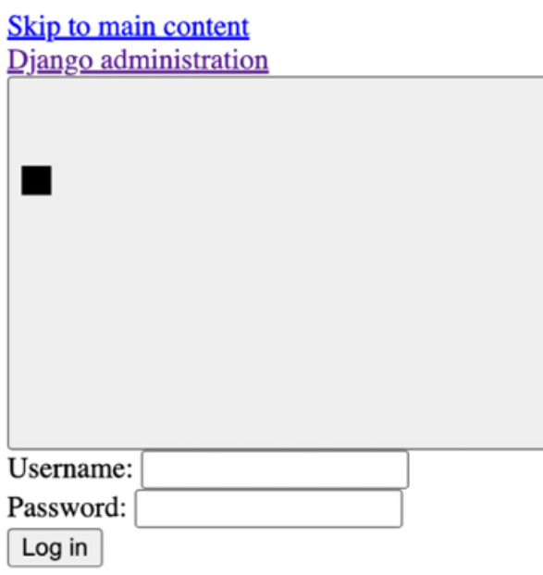
Figure 17.2: The Django administration site login form with no CSS styles applied

CSS styles are not loaded. You are using DEBUG=False , so URL patterns for serving static files are not being included in the main urls.py file of the project. Remember that the Django development server is not suitable for serving static files. You will configure a server for serving static files later in this chapter.

If you access any other URL of your site, you might get an HTTP 500 error because you haven’t configured a database for the production environment yet.

Take a look at the Docker Desktop app. You will see the following containers:
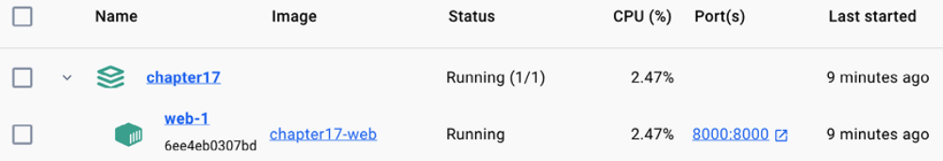
Figure 17.3: The chapter17 application and the web-1 container in Docker Desktop

The chapter17 Docker application is running and it has a single container named web-1 , which is running on port 8000 . The name for the Docker application is generated dynamically using the name of the directory where the Docker Compose file is located, in this case, chapter17 .

Under Images, you will see the image built for the web service, as in Figure 17.4:
Figure 17.4: The chapter17 application and the web-1 container in Docker Desktop

The chapter17-web image has been built using the Dockerfile you defined earlier and is used by the web-1 container.

Next, you are going to add a PostgreSQL service and a Redis service to your Docker application.

Configuring the PostgreSQL service
Throughout this book, you have mostly used the SQLite database. SQLite is simple and quick to set up, but for a production environment, you will need a more powerful database, such as PostgreSQL, MySQL, or Oracle. You used Docker to install PostgreSQL in Chapter 3, Extending Your Blog Application. You can find information about the official PostgreSQL Docker image at https://hub.docker.com/_/postgres.

Edit the docker-compose.yml file and add the following lines highlighted in bold:
services:
db:
image: postgres:16.2
restart: always
volumes:
- ./data/db:/var/lib/postgresql/data
environment:
- POSTGRES_DB=postgres
- POSTGRES_USER=postgres
- POSTGRES_PASSWORD=postgres
web:
build: .
command: python /code/educa/manage.py runserver 0.0.0.0:8000
restart: always
volumes:
- .:/code
ports:
- "8000:8000"
environment:
- DJANGO_SETTINGS_MODULE=educa.settings.prod
- POSTGRES_DB=postgres
- POSTGRES_USER=postgres
- POSTGRES_PASSWORD=postgres
depends_on:
- db

With these changes, you define a service named db with the following subsections:

- image : The service uses the base postgres Docker image.

- restart : The restart policy is set to always .

- volumes : You mount the ./data/db directory to the image directory /var/lib/postgresql/data to persist the database so that data stored in the database is maintained after the Docker application is stopped. This will create the local data/db/ path.

- environment : You use the POSTGRES_DB (database name), POSTGRES_USER , and POSTGRES_PASSWORD variables with default values.

The definition for the web service now includes the PostgreSQL environment variables for Django. You create a service dependency using depends_on so that the web service is started after the db service. This will guarantee the order of the container initialization, but it won’t guarantee that PostgreSQL is fully initiated before the Django web server is started. To solve this, you need to use a script that will wait on the availability of the
database host and its TCP port. Docker recommends that you use the waitfor- it tool to control container initialization.
Download the wait-for-it.sh bash script from
https://github.com/vishnubob/wait-forit/blob/master/wait-for-it.sh and save the file next to the docker-compose.yml file. Then, edit the docker-compose.yml file and modify the web service definition as follows. The new code is highlighted in bold:
web:
build: .
command: ["./wait-for-it.sh", "db:5432", "--",
"python", "/code/educa/manage.py", "runserver",
"0.0.0.0:8000"]
restart: always
volumes:
- .:/code
environment:
- DJANGO_SETTINGS_MODULE=educa.settings.prod
- POSTGRES_DB=postgres
- POSTGRES_USER=postgres
- POSTGRES_PASSWORD=postgres
depends_on:
- db

In this service definition, you use the wait-for-it.sh bash script to wait for the db host to be ready and accept connections on port 5432 , the default port for PostgreSQL, before starting the Django development server. You can read more about the service startup order in Compose at https://docs.docker.com/compose/startup-order/.

Let’s edit the Django settings. Edit the educa/settings/prod.py file and add the following code highlighted in bold:
from decouple import config
from .base import *
DEBUG = False
ADMINS = [
('Antonio M', 'email@mydomain.com'),
]
ALLOWED_HOSTS = ['*']
DATABASES = {
'default': {
'ENGINE': 'django.db.backends.postgresql',
'NAME': config('POSTGRES_DB'),
'USER': config('POSTGRES_USER'),
'PASSWORD': config('POSTGRES_PASSWORD'),
'HOST': 'db',
'PORT': 5432,
}
}

In the production settings file, you use the following settings:

- ENGINE : You use the Django database backend for PostgreSQL.

- NAME , USER , and PASSWORD : You use the config() function of pythondecouple to retrieve the POSTGRES_DB (database name), POSTGRES_USER , and POSTGRES_PASSWORD environment variables. You have set these environment variables in the Docker Compose file.

- HOST : You use db , which is the container hostname for the database service defined in the Docker Compose file. A container hostname defaults to the container’s ID in Docker. That’s why you use the db hostname.

- PORT : You use the 5432 value, which is the default port for PostgreSQL.

Stop the Docker application from the shell by pressing the Ctrl + C keys or using the stop button in the Docker Desktop app. Then, start Compose again with the following command:
docker compose up

The first execution after adding the db service to the Docker Compose file will take longer because PostgreSQL needs to initialize the database. The output will contain the following two lines:
db-1 | ... database system is ready to accept connections
...
web-1 | Starting ASGI/Daphne version 4.1.0 development server at

Both the PostgreSQL database and the Django application are ready. The production database is empty, so you need to apply database migrations.

Applying database migrations and creating a superuser
Open a different shell in the parent directory, where the docker-compose.yml file is located, and run the following command:
docker compose exec web python /code/educa/manage.py migrate

The docker compose exec command allows you to execute commands in the container. You use this command to execute the migrate management command in the web Docker container.

Finally, create a superuser with the following command:
docker compose exec web python /code/educa/manage.py createsuperu

Migrations have been applied to the database and you have created a superuser. You can access http://localhost:8000/admin/ with the superuser credentials. CSS styles still won’t load because you haven’t configured serving static files yet.

You have defined services to serve Django and PostgreSQL using Docker Compose. Next, you will add a service to serve Redis in the production environment.

Configuring the Redis service
Let’s add a Redis service to the Docker Compose file. For this purpose, you will use the official Redis Docker image. You can find information about the official Redis Docker image at https://hub.docker.com/_/redis.

Edit the docker-compose.yml file and add the following lines highlighted in
bold:
services:
db:
# ...
cache:
image: redis:7.2.4
restart: always
volumes:
- ./data/cache:/data
web:
# ...
depends_on:
- db
- cache

In the previous code, you define the cache service with the following subsections:

- image : The service uses the base redis Docker image.

- restart : The restart policy is set to always .

- volumes : You mount the ./data/cache directory to the /data image directory where any Redis writes will be persisted. This will create the local data/cache/ path.

In the web service definition, you add the cache service as a dependency, so that the web service is started after the cache service. The Redis server initializes fast, so you don’t need to use the wait-for-it tool in this case.

Edit the educa/settings/prod.py file and add the following lines:
REDIS_URL = 'redis://cache:6379'
CACHES['default']['LOCATION'] = REDIS_URL
CHANNEL_LAYERS['default']['CONFIG']['hosts'] = [REDIS_URL]

In these settings, you use the cache hostname that is automatically generated by Docker Compose using the name of the cache service and port 6379 used by Redis. You modify the Django CACHE setting and the CHANNEL_LAYERS setting used by Channels to use the production Redis URL.
Stop the Docker application from the shell by pressing the Ctrl + C keys or using the stop button in the Docker Desktop app. Then, start Compose again with the following command:
docker compose up
cache-1 | ... Ready to accept connections tcp

Open the Docker Desktop application. You should see now the chapter17 Docker application running a container for each service defined in the Docker Compose file: db , cache , and web , as in Figure 17.4:
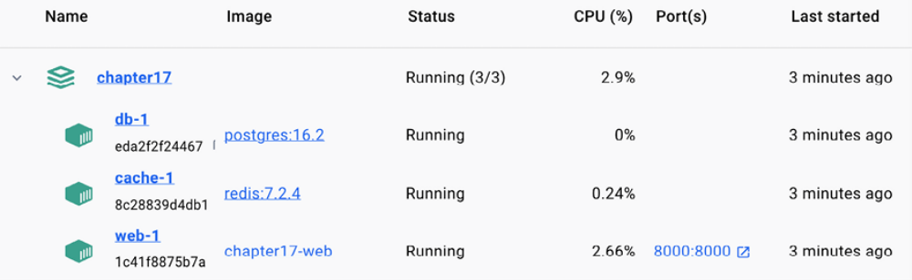
Figure 17.5: The chapter17 application with the db-1, web-1, and cache-1 containers in Docker Desktop

You are still serving Django with the Django development server, which, as you know, is meant for development only and not optimized for production use. Let’s replace it with the WSGI Python web server.

Serving Django through WSGI and NGINX
Django’s primary deployment platform is WSGI. WSGI stands for Web Server Gateway Interface , and it is the standard for serving Python applications on the web.

When you generate a new project using the startproject command, Django creates a wsgi.py file inside your project directory. This file contains a WSGI application callable, which is an access point to your application.

WSGI is used for both running your project with the Django development server and deploying your application with the server of your choice in a production environment. You can learn more about WSGI at https://wsgi.readthedocs.io/en/latest/.

In the following sections we will use uWSGI, an open source web server that implements the WSGI specification.
Using uWSGI
Throughout this book, you have been using the Django development server to run projects in your local environment. However, the development server is not designed for production use, and deploying your application in a production environment will require a standard web server.

uWSGI is an extremely fast Python application server. It communicates with your Python application using the WSGI specification. uWSGI translates web requests into a format that your Django project can process.

Let’s configure uWSGI to serve the Django project. You already added uwsgi==2.0.20 to the requirements.txt file of the project, so uWSGI is already being installed in the Docker image of the web service.

Edit the docker-compose.yml file and modify the web service definition as follows. The new code is highlighted in bold:
web:
build: .
command: ["./wait-for-it.sh", "db:5432", "--",
"uwsgi", "--ini", "/code/config/uwsgi/uwsgi.ini"]
restart: always
volumes:
- .:/code
environment:
- DJANGO_SETTINGS_MODULE=educa.settings.prod
- POSTGRES_DB=postgres
- POSTGRES_USER=postgres
- POSTGRES_PASSWORD=postgres
depends_on:
- db
- cache

Make sure to remove the ports section. uWSGI will be reachable with a socket, so you don’t need to expose a port in the container.

The new command for the image runs uwsgi and passes the /code/config/uwsgi/uwsgi.ini configuration file to it. Let’s create the configuration file for uWSGI.

Configuring uWSGI
uWSGI allows you to define a custom configuration in an .ini file. Next to the docker-compose.yml file, create the config/uwsgi/uwsgi.ini file path. Assuming your parent directory is named Chapter17 , the file structure should look as follows:
Chapter17/
config/
uwsgi/
uwsgi.ini
Dockerfile
docker-compose.yml
educa/
manage.py
...
requirements.txt

Edit the config/uwsgi/uwsgi.ini file and add the following code to it:
[uwsgi]
socket=/code/educa/uwsgi_app.sock
chdir = /code/educa/
module=educa.wsgi:application
master=true
chmod-socket=666
uid=www-data
gid=www-data
vacuum=true

In the uwsgi.ini file, you define the following options:

- socket : This is the Unix/TCP socket to bind the server.

- chdir : This is the path to your project directory, so that uWSGI changes to that directory before loading the Python application.

- module : This is the WSGI module to use. You set this to the

- application callable contained in the wsgi module of your project.

- master : This enables the master process.

- chmod-socket : These are the file permissions to apply to the socket file.In this case, you use 666 so that NGINX can read/write the socket.

- uid : This is the user ID of the process once it’s started.

- gid : This is the group ID of the process once it’s started.

- vacuum : Using true instructs uWSGI to clean up any temporary files or UNIX sockets it creates.

The socket option is intended for communication with some kind of thirdparty router, such as NGINX. You are going to run uWSGI using a socket and you are going to configure NGINX as your web server, which will communicate with uWSGI through the socket.

You can find the list of available uWSGI options at
https://uwsgidocs.readthedocs.io/en/latest/Options.html.

You will not be able to access your uWSGI instance from your browser now, since it’s running through a socket. To complete the environment, we will use NGINX in front of uWSGI, to manage HTTP requests and pass application requests to uWSGI through the socket. Let’s complete the production environment.

Using NGINX
When you are serving a website, you have to serve dynamic content, but you also need to serve static files, such as CSS style sheets, JavaScript files, and images. While uWSGI is capable of serving static files, it adds unnecessary overhead to HTTP requests and, therefore, it is encouraged to set up a web server, such as NGINX, in front of it.

NGINX is a web server focused on high concurrency, performance, and low memory usage. NGINX also acts as a reverse proxy, receiving HTTP and WebSocket requests and routing them to different backends.

Generally, you will use a web server, such as NGINX, in front of uWSGI for serving static files efficiently, and you will forward dynamic requests to uWSGI workers. By using NGINX, you can also apply different rules and benefit from its reverse proxy capabilities.

We will add the NGINX service to the Docker Compose file using the official NGINX Docker image. You can find information about the official NGINX Docker image at https://hub.docker.com/_/nginx.

Edit the docker-compose.yml file and add the following lines highlighted in bold:
services:
db:
# ...
cache:
# ...
web:
# ...
nginx:
Image: nginx:1.25.5
restart: always
volumes:
- ./config/nginx:/etc/nginx/templates
- .:/code
ports:
- "80:80"

You have added the definition for the nginx service with the following subsections:

- image : The service uses the base nginx Docker image.

- restart : The restart policy is set to always .

- volumes : You mount the ./config/nginx volume to the /etc/nginx/templates directory of the Docker image. This is where NGINX will look for a default configuration template. You also mount the local directory . to the /code directory of the image, so that NGINX can have access to static files.

- ports : You expose port 80 , which is mapped to container port 80 . This is the default port for HTTP.

Let’s configure the NGINX web server.

Configuring NGINX
Create the following file path highlighted in bold under the config/ directory:
config/
uwsgi/
uwsgi.ini
nginx/
default.conf.template

Edit the nginx/default.conf.template file and add the following code to it:
# upstream for uWSGI
upstream uwsgi_app {
server unix:/code/educa/uwsgi_app.sock;
}
server {
listen 80;
server_name www.educaproject.com educaproject.com;
error_log stderr warn;
access_log /dev/stdout main;
location / {
include /etc/nginx/uwsgi_params;
uwsgi_pass uwsgi_app;
}
}
This is the basic configuration for NGINX. In this configuration, you set up an upstream component named uwsgi_app , which points to the socket created by uWSGI. You use the server block with the following configuration:

- You tell NGINX to listen on port 80 .

- You set the server name to both www.educaproject.com and educaproject.com . NGINX will serve incoming requests for both domains.

- You use stderr for the error_log directive to get error logs written to the standard error file. The second parameter determines the logging level. You use warn to get warnings and errors of higher severity.

- You point access_log to the standard output with /dev/stdout .

- You specify that any request under the / path has to be routed with the uwsgi_app socket to uWSGI.

- You include the default uWSGI configuration parameters that come with NGINX. These are located at /etc/nginx/uwsgi_params .

NGINX is now configured. You can find the NGINX documentation at
https://nginx.org/en/docs/.

Stop the Docker application from the shell by pressing the Ctrl + C keys or using the stop button in the Docker Desktop app. Then, start Compose again with the following command:
docker compose up

Open the http://localhost/ URL in your browser. It’s not necessary to add a port to the URL because you are accessing the host through the standard HTTP port 80 . You should see the course list page with no CSS styles, like Figure 17.6:

Figure 17.6: The course list page served with NGINX and uWSGI
The following diagram shows the request/response cycle of the production environment that you have set up:
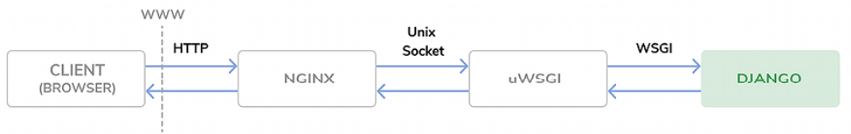
Figure 17.7: The production environment request/response cycle

The following happens when the client browser sends an HTTP request:

1. NGINX receives the HTTP request.

2. NGINX delegates the request to uWSGI through a socket.

3. uWSGI passes the request to Django for processing.

4. Django returns an HTTP response that is passed back to NGINX, which in turn passes it back to the client browser.

If you check the Docker Desktop application, you should see that there are four containers running:

- The db service is running PostgreSQL

- The cache service is running Redis

- The web service is running uWSGI and Django

- The nginx service is running NGINX

Let’s continue with the production environment setup. Instead of accessing our project using localhost , we will configure the project to use the educaproject.com hostname.

Using a hostname
You will use the educaproject.com hostname for your site. Since you are using a sample domain name, you need to redirect it to your local host.
If you are using Linux or macOS, edit the /etc/hosts file and add the following line to it:
127.0.0.1 educaproject.com www.educaproject.com
If you are using Windows, edit the C:\Windows\System32\drivers\etc file and add the same line.
By doing so, you are routing the educaproject.com and www.educaproject.com hostnames to your local server. In a production server, you won’t need to do this, since you will have a fixed IP address and you will point your hostname to your server in your domain’s DNS
configuration.

Open http://educaproject.com/ in your browser. You should be able to see your site, still without any static assets loaded. Your production environment is almost ready.

Now, you can restrict the hosts that can serve your Django project. Edit the educa/settings/prod.py production settings file of your project and change the ALLOWED_HOSTS setting, as follows:
ALLOWED_HOSTS = ['educaproject.com', 'www.educaproject.com']

Django will only serve your application if it’s running under any of these hostnames. You can read more about the ALLOWED_HOSTS setting at
https://docs.djangoproject.com/en/5.0/ref/settings/#allowed-hosts.

The production environment is almost ready. Let’s continue by configuring NGINX to serve static files.

Serving static and media assets
uWSGI is capable of serving static files flawlessly, but it is not as fast and effective as NGINX. For the best performance, you will use NGINX to serve static files in your production environment. You will set up NGINX to serve both the static files of your application (CSS style sheets, JavaScript files, and images) and media files uploaded by instructors for the course contents.

Edit the settings/base.py file and add the following line just below the
STATIC_URL setting:
STATIC_ROOT = BASE_DIR / 'static'

This is the root directory for all static files of the project. Next, you are going to collect the static files from the different Django applications into the common directory.

Collecting static files
Each application in your Django project may contain static files in a static/ directory. Django provides a command to collect static files from all applications into a single location. This simplifies the setup for serving static files in production. The collectstatic command collects the static files from all applications of the project into the path defined with the STATIC_ROOT setting.

Stop the Docker application from the shell by pressing the Ctrl + C keys or using the stop button in the Docker Desktop app. Then, start Compose again with the following command:
docker compose up

Open another shell in the parent directory, where the docker-compose.yml file is located, and run the following command:
docker compose exec web python /code/educa/manage.py collectstati

Note that you can alternatively run the following command in the shell, from the educa/ project directory:
python manage.py collectstatic --settings=educa.settings.local

Both commands will have the same effect since the base local directory is mounted to the Docker image. Django will ask whether you want to override any existing files in the root directory. Type yes and press Enter. You will see the following output:
171 static files copied to '/code/educa/static'.

Files located under the static/ directory of each application present in the INSTALLED_APPS setting have been copied to the global /educa/static/ project directory.

Serving static files with NGINX
Edit the config/nginx/default.conf.template file and add the following lines highlighted in bold to the server block:
server {
# ...
location / {
include /etc/nginx/uwsgi_params;
uwsgi_pass uwsgi_app;
}
location /static/ {
alias /code/educa/static/;
}
location /media/ {
alias /code/educa/media/;
}
}

These directives tell NGINX to serve static files located under the /static/ and /media/ paths directly. These paths are as follows:

/static/ : This corresponds to the path of the STATIC_URL setting. The target path corresponds to the value of the STATIC_ROOT setting. You use it to serve the static files of your application from the directory mounted to the NGINX Docker image.

/media/ : This corresponds to the path of the MEDIA_URL setting, and its target path corresponds to the value of the MEDIA_ROOT setting. You use it to serve the media files uploaded to the course contents from the directory mounted to the NGINX Docker image.

Figure 17.8 shows the current setup of the production environment:
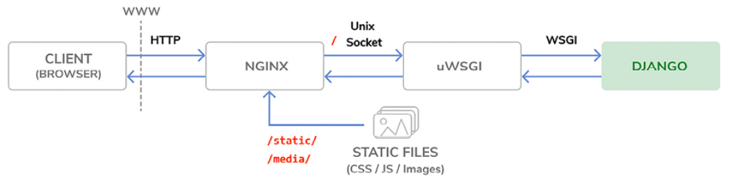
Figure 17.8: The production environment request/response cycle, including static files

Files under the /static/ and /media/ paths are now served by NGINX directly, instead of being forwarded to uWSGI. Requests to any other path are still passed by NGINX to uWSGI through the UNIX socket.

Stop the Docker application from the shell by pressing the Ctrl + C keys or using the stop button in the Docker Desktop app. Then, start Compose again with the following command:
docker compose up

Open http://educaproject.com/ in your browser. You should see the following screen:

Figure 17.9: The course list page served with NGINX and uWSGI
Static resources, such as CSS style sheets and images, are now loaded correctly. HTTP requests for static files are now being served by NGINX directly, instead of being forwarded to uWSGI.

You have successfully configured NGINX for serving static files. Next, you are going to perform some checks on your Django project to validate it for a production environment and you are going to serve your site under HTTPS.

Securing your site with SSL/TLS
The TLS protocol is the standard for serving websites through a secure connection. The TLS predecessor is SSL. Although SSL is now deprecated, in multiple libraries and online documentation, you will find references to both the terms TLS and SSL. It’s strongly encouraged that you serve your websites over HTTPS.

In this section, you are going to check your Django project for any issues and validate it for a production deployment. You will also prepare the project to be served over HTTPS. Then, you are going to configure an SSL/TLS certificate in NGINX to serve your site securely.

Checking your project for production
Django includes a system check framework for validating your project at any time. The check framework inspects the applications installed in your Django project and detects common problems. Checks are triggered implicitly when you run management commands like runserver and migrate . However, you can trigger checks explicitly with the check management command.

You can read more about Django’s system check framework at
https://docs.djangoproject.com/en/5.0/topics/checks/.

Let’s confirm that the check framework does not raise any issues for your project. Open the shell in the educa project directory and run the following command to check your project:
python manage.py check --settings=educa.settings.prod

You will see the following output:
System check identified no issues (0 silenced).

The system check framework didn’t identify any issues. If you use the -- deploy option, the system check framework will perform additional checks that are relevant for a production deployment.

Run the following command from the educa project directory:
python manage.py check --deploy --settings=educa.settings.prod

You will see an output like the following:
System check identified some issues:
WARNINGS:
(security.W004) You have not set a value for the SECURE_HSTS_SECO
(security.W008) Your SECURE_SSL_REDIRECT setting is not set to Tr
(security.W009) Your SECRET_KEY has less than 50 characters, less
(security.W012) SESSION_COOKIE_SECURE is not set to True. ...
(security.W016) You have 'django.middleware.csrf.CsrfViewMiddlewa
System check identified 5 issues (0 silenced).

The check framework has identified five issues (zero errors and five warnings). All warnings are related to security-related settings.

Let’s address the security.W009 issue. Edit the educa/settings/base.py file and modify the SECRET_KEY setting by removing the django-insecureprefix and adding additional random characters to generate a string with at least 50 characters.

Run the check command again and verify that the security.W009 issue is not raised anymore. The rest of the warnings are related to SSL/TLS configuration. We will address them next.

Configuring your Django project for SSL/TLS
Django comes with specific settings for SSL/TLS support. You are going to edit the production settings to serve your site over HTTPS.

Edit the educa/settings/prod.py settings file and add the following settings to it:
# Security
CSRF_COOKIE_SECURE = True
SESSION_COOKIE_SECURE = True
SECURE_SSL_REDIRECT = True

These settings are as follows:

- CSRF_COOKIE_SECURE : Use a secure cookie for cross-site request forgery (CSRF) protection. With True , browsers will only transfer the cookie over HTTPS.

- SESSION_COOKIE_SECURE : Use a secure session cookie. With True , browsers will only transfer the cookie over HTTPS.

- SECURE_SSL_REDIRECT : This indicates whether HTTP requests have to be redirected to HTTPS.

Django will now redirect HTTP requests to HTTPS; session and CSRF cookies will be sent only over HTTPS.

Run the following command from the main directory of your project:
python manage.py check --deploy --settings=educa.settings.prod

Only one warning remains, security.W004 :
(security.W004) You have not set a value for the SECURE_HSTS_SECO

This warning is related to the HTTP Strict Transport Security (HSTS) policy. The HSTS policy prevents users from bypassing warnings and connecting to a site with an expired, self-signed, or otherwise invalid SSL certificate. In the next section, we will use a self-signed certificate for our site, so we will ignore this warning.

When you own a real domain, you can apply for a trusted Certificate Authority (CA) to issue an SSL/TLS certificate for it, so that browsers can verify its identity. In that case, you can give a value to SECURE_HSTS_SECONDS higher than 0 , which is the default value. You can learn more about the HSTS policy at
https://docs.djangoproject.com/en/5.0/ref/middleware/#http-strict-transport-security.

You have successfully fixed the rest of the issues raised by the check framework. You can read more about the Django deployment checklist at
https://docs.djangoproject.com/en/5.0/howto/deployment/checklist/.

Creating an SSL/TLS certificate
Create a new directory inside the educa project directory and name it ssl . Then, generate an SSL/TLS certificate from the command line with the following command:
openssl req -x509 -newkey rsa:2048 -sha256 -days 3650 -nodes \
-keyout ssl/educa.key -out ssl/educa.crt \
-subj '/CN=*.educaproject.com' \
-addext 'subjectAltName=DNS:*.educaproject.com'

This will generate a private key and a 2048-bit SSL/TLS certificate that is valid for 10 years. This certificate is issued for the *.educaproject.com hostname. This is a wildcard certificate; by using the * wildcard character in the domain name, the certificate can be used for any subdomain of educaproject.com , such as www.educaproject.com or django.educaproject.com . After generating the certificate, the educa/ssl/ directory will contain two files: educa.key (the private key) and educa.crt (the certificate).

You will need at least OpenSSL 1.1.1 or LibreSSL 3.1.0 to use the -addext option. You can check the OpenSSL location in your machine with the which openssl command and you can check the version with the openssl version command.

Alternatively, you can use the SSL/TLS certificate provided in the source code for this chapter. You will find the certificate at
https://github.com/PacktPublishing/Django-5-byexample/
blob/main/Chapter17/educa/ssl/. Note that you should generate a private key and not use this certificate in production.

Configuring NGINX to use SSL/TLS
Edit the docker-compose.yml file and add the following line highlighted in
bold:
services:
# ...
nginx:
#...
ports:
- "80:80"
- "443:443"

The NGINX container host will be accessible through port 80 (HTTP) and port 443 (HTTPS). The host port 443 is mapped to the container port 443 .

Edit the config/nginx/default.conf.template file of the educa project and edit the server block to include SSL/TLS, as follows:
server {
listen 80;
listen 443 ssl;
ssl_certificate /code/educa/ssl/educa.crt;
ssl_certificate_key /code/educa/ssl/educa.key;
server_name www.educaproject.com educaproject.com;
# ...
}

With the preceding code, NGINX now listens both to HTTP over port 80 and HTTPS over port 443 . You indicate the path to the SSL/TLS certificate with ssl_certificate and the certificate key with ssl_certificate_key .

Stop the Docker application from the shell by pressing the Ctrl + C keys or using the stop button in the Docker Desktop app. Then, start Compose again with the following command:
docker compose up

Open https://educaproject.com/ with your browser. You should see a warning message similar to the following one:
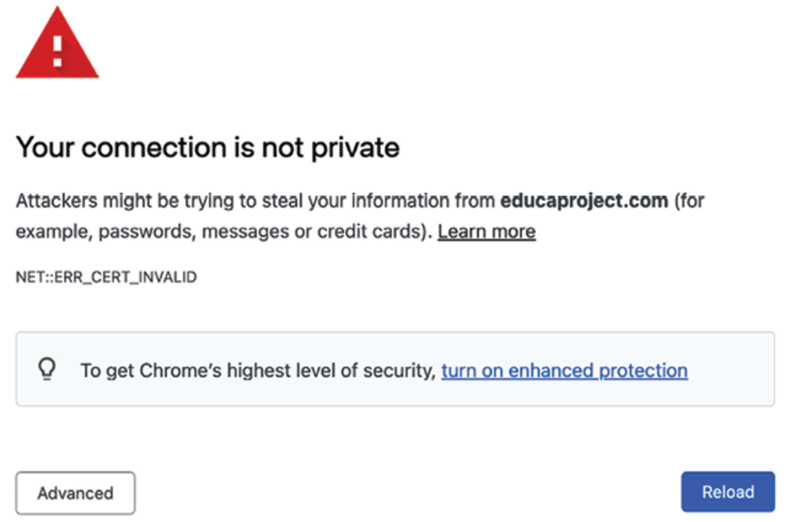
Figure 17.10: An invalid certificate warning

This screen might vary depending on your browser. It alerts you that your site is not using a trusted or valid certificate; the browser can’t verify the identity of your site. This is because you signed your own certificate instead of obtaining one from a trusted CA. When you own a real domain, you can apply for a trusted CA to issue an SSL/TLS certificate for it, so that browsers can verify its identity. If you want to obtain a trusted certificate for a real domain, you can refer to the Let’s Encrypt project created by the Linux Foundation. It is a nonprofit CA that simplifies obtaining and renewing trusted SSL/TLS certificates for free. You can find more information at https://letsencrypt.org.

Click on the link or button that provides additional information and choose to visit the website, ignoring warnings. The browser might ask you to add an exception for this certificate or verify that you trust it. If you are using Chrome, you might not see any option to proceed to the website. If this is the case, type thisisunsafe and press Enter directly in Chrome on the warning page. Chrome will then load the website. Note that you do this with your own issued certificate; don’t trust any unknown certificate or bypass the browser SSL/TLS certificate checks for other domains.

When you access the site, the browser will display a lock icon next to the URL like Figure 17.11:

Figure 17.11: The browser address bar, including a secure connection padlock icon

Other browsers might display a warning indicating that the certificate is not trusted, like Figure 17.12:

Figure 17.12: The browser address bar, including a warning message

Your browser might mark the certificate as unsafe, but you are using it for testing purposes only. You are now serving your site securely over HTTPS.

Redirecting HTTP traffic over to HTTPS
You are redirecting HTTP requests to HTTPS with Django using the SECURE_SSL_REDIRECT setting. Any request using http:// is redirected to the same URL using https:// . However, this can be handled in a more efficient manner using NGINX.

Edit the config/nginx/default.conf.template file and add the following
lines highlighted in bold:
# upstream for uWSGI
upstream uwsgi_app {
server unix:/code/educa/uwsgi_app.sock;
}
server {
listen 80;
server_name www.educaproject.com educaproject.com;
return 301 https://$host$request_uri;
}
server {
listen 443 ssl;
ssl_certificate /code/educa/ssl/educa.crt;
ssl_certificate_key /code/educa/ssl/educa.key;
server_name www.educaproject.com educaproject.com;
# ...
}
In this code, you remove the directive listen 80; from the original server block, so that the platform is only available over HTTPS (port 443 ). On top of the original server block, you add an additional server block that only listens on port 80 and redirects all HTTP requests to HTTPS. To achieve this, you return an HTTP response code 301 (permanent redirect) that redirects to the https:// version of the requested URL using the $host and $request_uri variables.

Open a shell in the parent directory, where the docker-compose.yml file is located, and run the following command to reload NGINX:
docker compose exec nginx nginx -s reload

This runs the nginx -s reload command in the nginx container. You are now redirecting all HTTP traffic to HTTPS using NGINX.

Your environment is now secured with TLS/SSL. To complete the production environment setup, the only remaining step is integrating Daphne to handle asynchronous requests, and get our course chat rooms running in production.

Configuring Daphne for Django Channels
In Chapter 16, Building a Chat Server, you used Django Channels to build a chat server using WebSockets and you used Daphne to serve asynchronous requests by replacing the standard Django runserver command. We will add Daphne to our production environment.

Let’s create a new service in the Docker Compose file to run the Daphne web server.
Edit the docker-compose.yml file and add the following lines inside the
services block:
daphne:
build: .
working_dir: /code/educa/
command: ["../wait-for-it.sh", "db:5432", "--",
"daphne", "-b", "0.0.0.0", "-p", "9001",
"educa.asgi:application"]
restart: always
volumes:
- .:/code
environment:
- DJANGO_SETTINGS_MODULE=educa.settings.prod
- POSTGRES_DB=postgres
- POSTGRES_USER=postgres
- POSTGRES_PASSWORD=postgres
depends_on:
- db
- cache

The daphne service definition is very similar to the web service. The image for the daphne service is also built with the Dockerfile you previously created for the web service. The main differences are as follows:

- working_dir changes the working directory of the image to /code/educa/ .

- command runs the educa.asgi:application application defined in the educa/asgi.py file with daphne in the 0.0.0.0 hostname and port 9001 . It also uses the wait-for-it bash script to wait for the PostgreSQL database to be ready before initializing the web server.

Since you are running Django on production, Django checks the ALLOWED_HOSTS when receiving HTTP requests. We will implement the same validation for WebSocket connections.

Edit the educa/asgi.py file of your project and add the following lines
highlighted in bold:
import os
from django.core.asgi import get_asgi_application
from channels.routing import ProtocolTypeRouter, URLRouter
from channels.security.websocket import AllowedHostsOriginValida
from channels.auth import AuthMiddlewareStack
os.environ.setdefault('DJANGO_SETTINGS_MODULE', 'educa.settings'
django_asgi_app = get_asgi_application()
from chat.routing import websocket_urlpatterns
application = ProtocolTypeRouter({
'http': django_asgi_app,
'websocket': AllowedHostsOriginValidator(
AuthMiddlewareStack(
URLRouter(websocket_urlpatterns)
)
),
})

The Channels configuration is now ready for production.

Using secure connections for WebSockets
You have configured NGINX to use secure connections with SSL/TLS. You need to change ws (WebSocket) connections to use the wss (WebSocket Secure) protocol now, in the same way that HTTP connections are now being served over HTTPS.

Edit the chat/room.html template of the chat application and find the following line in the domready block:
const url = 'ws://' + window.location.host +

Replace that line with the following one:
const url = 'wss://' + window.location.host +

By using wss:// instead of ws:// , you are explicitly connecting to a secure WebSocket.

Including Daphne in the NGINX configuration
In your production setup, you will run Daphne on a UNIX socket and use NGINX in front of it. NGINX will pass requests to Daphne based on the requested path. You will expose Daphne to NGINX through a UNIX socket interface, just like the uWSGI setup.

Edit the config/nginx/default.conf.template file and make it look as follows:
# upstream for uWSGI
upstream uwsgi_app {
server unix:/code/educa/uwsgi_app.sock;
}
# upstream for Daphne
upstream daphne {
server daphne:9001;
}
server {
listen 80;
server_name www.educaproject.com educaproject.com;
return 301 https://$host$request_uri;
}
server {
listen 443 ssl;
ssl_certificate /code/educa/ssl/educa.crt;
ssl_certificate_key /code/educa/ssl/educa.key;
server_name www.educaproject.com educaproject.com;
error_log stderr warn;
access_log /dev/stdout main;
location / {
include /etc/nginx/uwsgi_params;
uwsgi_pass uwsgi_app;
}
location /ws/ {
proxy_pass http://daphne;
proxy_http_version 1.1;
proxy_set_header Upgrade $http_upgrade;
proxy_set_header Connection "upgrade";
proxy_redirect off;
}
location /static/ {
alias /code/educa/static/;
}
location /media/ {
alias /code/educa/media/;
}
}

In this configuration, you set up a new upstream named daphne , which points to the daphne host and port 9001 . In the server block, you configure the /ws/ location to forward requests to Daphne. You use the proxy_pass directive to pass requests to Daphne and you include some additional proxy directives.

With this configuration, NGINX will pass any URL request that starts with the /ws/ prefix to Daphne and the rest to uWSGI, except for files under the /static/ or /media/ paths, which will be served directly by NGINX.

Figure 17.13 shows the final production setup, including the Daphne server:
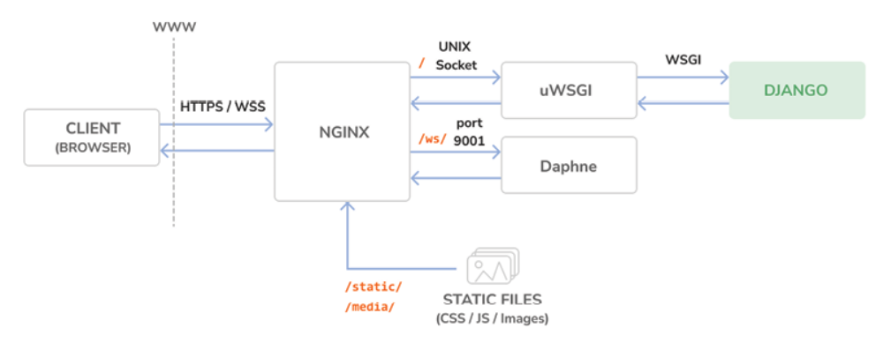
Figure 17.13: The production environment request/response cycle, including Daphne

NGINX runs in front of uWSGI and Daphne as a reverse proxy server. NGINX faces the web and passes requests to the application server (uWSGI or Daphne) based on their path prefix. Besides this, NGINX also serves static files and redirects non-secure requests to secure ones. This setup reduces downtime, consumes fewer server resources, and provides greater performance and security.

Stop the Docker application from the shell by pressing the Ctrl + C keys or using the stop button in the Docker Desktop app. Then, start Compose again with the following command:
docker compose up

Use your browser to create a sample course with an instructor user, log in with a user who is enrolled in the course, and open https://educaproject.com/chat/room/1/ with your browser. You should be able to send and receive messages like the following example:
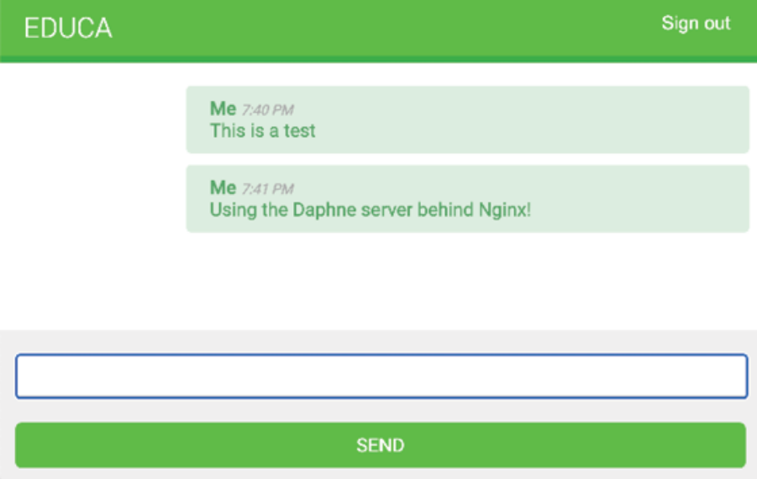
Figure 17.14: Course chat room messages served with NGINX and Daphne

Daphne is working correctly, and NGINX is passing WebSocket requests to it. All connections are secured with SSL/TLS.

Congratulations! You have built a custom production-ready stack using NGINX, uWSGI, and Daphne. You could do further optimization for additional performance and enhanced security through configuration settings in NGINX, uWSGI, and Daphne. However, this production setup is a great start!

You have used Docker Compose to define and run services in multiple containers. Note that you can use Docker Compose both for local development environments as well as production environments. You can find additional information on using Docker Compose in production at https://docs.docker.com/compose/production/.

For more advanced production environments, you will need to dynamically distribute containers across a varying number of machines. For that, instead of Docker Compose, you will need an orchestrator like Docker Swarm mode or Kubernetes. You can find information about the Docker Swarm mode at https://docs.docker.com/engine/swarm/, and about Kubernetes at https://kubernetes.io/docs/home/.

Note that managing systems and cloud infrastructure demands expertise in configuration, optimization, and security. To ensure a secure and efficient production environment, consider bringing a systems/DevOps expert on board or enhancing your own expertise in these areas.

Now that we have a complete environment that processes HTTP requests in a performant manner, it’s a good time to dive into middleware for request/response processing across our application.

Creating a custom middleware
You already know the MIDDLEWARE setting, which contains the middleware for your project. You can think of it as a low-level plugin system, allowing you to implement hooks that get executed in the request/response process.

Each middleware is responsible for some specific action that will be executed for all HTTP requests or responses.


You should avoid adding expensive processing to middleware since they are executed in every single request.

Figure 17.15 shows the middleware execution in Django:
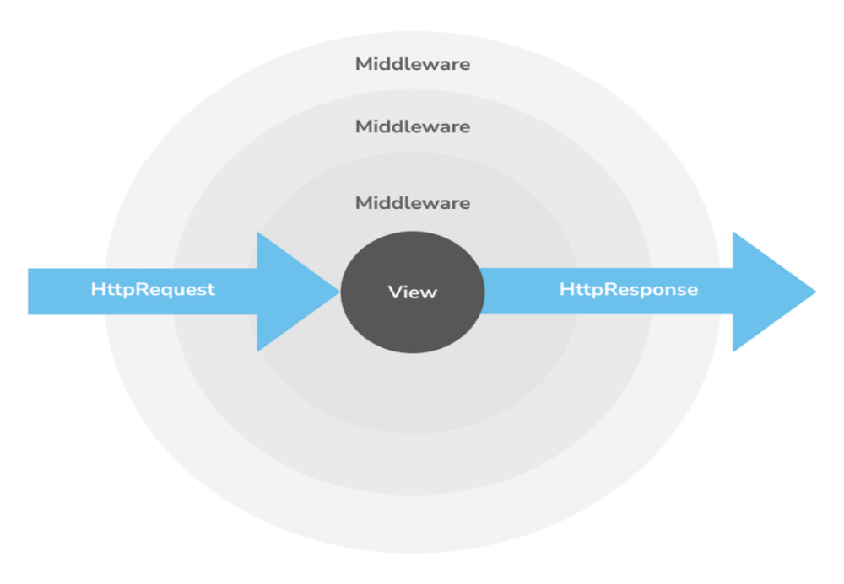
Figure 17.15: Middleware execution in Django
When an HTTP request is received, middleware is executed in order of appearance in the MIDDLEWARE setting. When an HTTP response has been generated by Django, the response passes through all middleware back in reverse order.

Figure 17.16 shows the execution order of the middleware components included in the MIDDLEWARE setting when creating a project with the startproject management command:
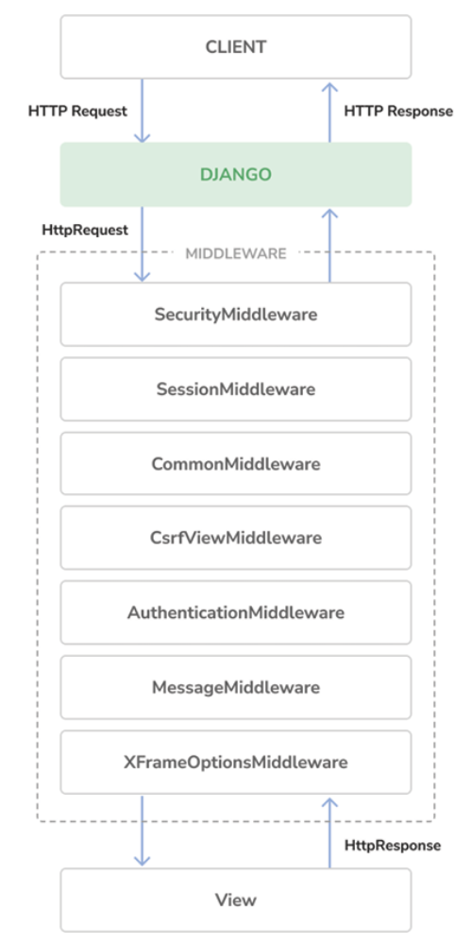
Figure 17.16: Execution order for default middleware components

Middleware can be written as a function, as follows:
def my_middleware(get_response):
def middleware(request):
# Code executed for each request before
# the view (and later middleware) are called.
response = get_response(request)
# Code executed for each request/response after
# the view is called.
return response
return middleware

A middleware factory is a callable that takes a get_response callable and returns middleware. The middleware callable takes a request and returns a response, just like a view. The get_response callable might be the next middleware in the chain or the actual view in the case of the last listed middleware.

If any middleware returns a response without calling its get_response callable, it short-circuits the process; no further middleware gets executed (nor does the view), and the response returns through the same layers that the request passed in through.

The order of middleware components in the MIDDLEWARE setting is very important because each component may depend on the data set in the request by other middleware components executed previously.

When adding a new middleware to the MIDDLEWARE setting, make sure to place it in the right position. You can find more information about middleware at
https://docs.djangoproject.com/en/5.0/topics/http/middleware/.

Creating subdomain middleware
You are going to create custom middleware to allow courses to be accessible through a custom subdomain. Each course detail URL, which looks like https://educaproject.com/course/django/ , will also be accessible through the subdomain that makes use of the course slug, such as https://django.educaproject.com/ . Users will be able to use the subdomain as a shortcut to access the course details. Any requests to subdomains will be redirected to each corresponding course detail URL.
Middleware can reside anywhere within your project. However, it’s recommended that you create a middleware.py file in your application directory.

Create a new file inside the courses application directory and name it middleware.py . Add the following code to it:
from django.urls import reverse
from django.shortcuts import get_object_or_404, redirect
from .models import Course
def subdomain_course_middleware(get_response):
"""
Subdomains for courses
"""
def middleware(request):
host_parts = request.get_host().split('.')
if len(host_parts) > 2 and host_parts[0] != 'www':
# get course for the given subdomain
course = get_object_or_404(Course, slug=host_parts[0
course_url = reverse('course_detail', args=[course.s
# redirect current request to the course_detail view
url = '{}://{}{}'.format(
request.scheme, '.'.join(host_parts[1:]), course
)
return redirect(url)
response = get_response(request)
return response
return middleware

When an HTTP request is received, you perform the following tasks:

1. You get the hostname that is being used in the request and divide it into parts. For example, if the user is accessing mycourse.educaproject.com , you generate the ['mycourse', 'educaproject', 'com'] list.

2. You check whether the hostname includes a subdomain by checking whether the split generated more than two elements. If the hostname includes a subdomain, and this is not www , you try to get the course with the slug provided in the subdomain.

3. If a course is not found, you raise an HTTP 404 exception. Otherwise, you redirect the browser to the course detail URL.

Edit the settings/base.py file of the project and add 'courses.middleware.subdomain_course_middleware' at the bottom of the MIDDLEWARE list, as follows:
MIDDLEWARE = [
# ...
'courses.middleware.subdomain_course_middleware',
]

The middleware will now be executed in every request. Remember that the hostnames allowed to serve your Django project are specified in the ALLOWED_HOSTS setting. Let’s change this setting so that any possible subdomain of educaproject.com is allowed to serve your application.

Edit the educa/settings/prod.py file and modify the ALLOWED_HOSTS setting, as follows:
ALLOWED_HOSTS = ['.educaproject.com']

A value that begins with a period is used as a subdomain wildcard; '.educaproject.com' will match educaproject.com and any subdomain for this domain, for example, course.educaproject.com and django.educaproject.com .

Serving multiple subdomains with NGINX
You need NGINX to be able to serve your site with any possible subdomain.

Edit the config/nginx/default.conf.template file at these two occurrences:
server_name www.educaproject.com educaproject.com;

Replace the occurences of the preceding line with the following one:
server_name *.educaproject.com educaproject.com;

By using the asterisk, this rule applies to all subdomains of educaproject.com . In order to test your middleware locally, you need to add any subdomains you want to test to /etc/hosts . For testing the middleware with a Course object with the slug django , add the following line to your /etc/hosts file:
127.0.0.1 django.educaproject.com

Stop the Docker application from the shell by pressing the Ctrl + C keys or using the stop button in the Docker Desktop app. Then, start Compose again with the following command:
docker compose up

Then, open https://django.educaproject.com/ in your browser. The middleware will find the course by the subdomain and redirect your browser to https://educaproject.com/course/django/ .

Your custom subdomain middleware is working!

Now, we will delve into a final topic that is extremely useful for projects:
automating tasks and making them available as commands.

Implementing custom management commands
Django allows your applications to register custom management commands for the manage.py utility. For example, you used the makemessages and compilemessages management commands in Chapter 11, Adding Internationalization to Your Shop, to create and compile translation files.

A management command consists of a Python module containing a Command class that inherits from django.core.management.base.BaseCommand or one of its subclasses. You can create simple commands or make them take positional and optional arguments as input.

Django looks for management commands in the management/commands/ directory for each active application in the INSTALLED_APPS setting. Each module found is registered as a management command named after it.

You can learn more about custom management commands at
https://docs.djangoproject.com/en/5.0/howto/custommanagement-commands/.

You are going to create a custom management command to remind students to enroll in at least one course. The command will send an email reminder to users who have been registered for longer than a specified period and who aren’t enrolled in any course yet.

Create the following file structure inside the students application directory:
management/
__init__.py
commands/
__init__.py
enroll_reminder.py

Edit the enroll_reminder.py file and add the following code to it:
import datetime
from django.conf import settings
from django.contrib.auth.models import User
from django.core.mail import send_mass_mail
from django.core.management.base import BaseCommand
from django.db.models import Count
from django.utils import timezone
class Command(BaseCommand):
help = 'Sends an e-mail reminder to users registered more' \
'than N days that are not enrolled into any courses y
def add_arguments(self, parser):
parser.add_argument('--days', dest='days', type=int)
def handle(self, *args, **options):
emails = []
subject = 'Enroll in a course'
date_joined = timezone.now().today() - datetime.timedelt
days=options['days'] or 0
)
users = User.objects.annotate(
course_count=Count('courses_joined')
).filter(course_count=0, date_joined__date__lte=date_joi
for user in users:
message = f"""Dear {user.first_name},
We noticed that you didn't enroll in any courses yet
What are you waiting for?"""
emails.append(
(
subject,
message,
settings.DEFAULT_FROM_EMAIL,
[user.email]
)
)
send_mass_mail(emails)
self.stdout.write(f'Sent {len(emails)} reminders')

This is your enroll_reminder command. The preceding code is as follows:

- The Command class inherits from BaseCommand .

- You include a help attribute. This attribute provides a short description of the command that is printed if you run the python manage.py help enroll_reminder command.

- You use the add_arguments() method to add the --days named argument. This argument is used to specify the minimum number of days a user has to be registered, without having enrolled in any course, in order to receive the reminder.

- The handle() command contains the actual command. You get the days attribute parsed from the command line. If this is not set, you use 0 , so that a reminder is sent to all users that haven’t enrolled on a course, regardless of when they registered. You use the timezone utility provided by Django to retrieve the current timezone-aware date with
timezone.now().date() . (You can set the timezone for your project with the TIME_ZONE setting.) You retrieve the users who have been registered for more than the specified days and are not enrolled in any courses yet. You achieve this by annotating the QuerySet with the total number of courses each user is enrolled in. You generate the reminder email for each user and append it to the emails list. Finally, you send the emails using the send_mass_mail() function, which is optimized to open a single SMTP connection for sending all emails, instead of opening one connection per email sent.

You have created your first management command. Open the shell and run your command:
docker compose exec web python /code/educa/manage.py \enroll_reminder --days=20 --settings=educa.settings.prod

If you don’t have a local SMTP server running, you can look at Chapter 2, Enhancing Your Blog with Advanced Features, where you configured the SMTP settings for your first Django project. Alternatively, you can add the following setting to the base.py file to make Django output emails to the standard output during development:
EMAIL_BACKEND = 'django.core.mail.backends.console.EmailBackend'

Django also includes a utility to call management commands using Python.
You can run management commands from your code as follows:
from django.core import management
management.call_command('enroll_reminder', days=20)

Congratulations! You can now create custom management commands for your applications.

Django management commands can be scheduled to run automatically using tools like cron or Celery Beat. Cron is a time-based job scheduler in Unixlike operating systems that enables users to schedule scripts or commands to run at specified times and intervals. You can read more about cron at https://en.wikipedia.org/wiki/Cron. On the other hand,

Celery Beat is a scheduler that works with Celery to run functions at designated intervals. You can learn more about Celery Beat at
https://docs.celeryq.dev/en/stable/userguide/periodic-tasks.html. By using either cron or Celery Beat, you can ensure your tasks are executed regularly without manual intervention.

Summary
In this chapter, you created a production environment using Docker Compose. You configured NGINX, uWSGI, and Daphne to serve your application in production. You secured your environment using SSL/TLS. You also implemented custom middleware and you learned how to create custom management commands.

You have reached the end of this book. Congratulations! You have learned the skills required to build successful web applications with Django. This book has guided you through the process of developing real-life projects and integrating Django with other technologies. Now, you are ready to create your own Django project, whether it is a simple prototype or a large-scale web application.

Good luck with your next Django adventure!

Expanding your project using AI
In this section, you are presented with a task to extend your project, accompanied by a sample prompt for ChatGPT to assist you. To engage with ChatGPT, visit https://chat.openai.com/. If this is your first interaction with ChatGPT, you can revisit the Expanding your project using AI section in Chapter 3, Extending Your Blog Application.

We have developed a comprehensive e-learning platform. However, when students are enrolled in multiple courses, each containing several modules, it can be challenging for them to remember where they last left off. To address this, let’s use ChatGPT in conjunction with Redis to store and retrieve each student’s progress within a course. For guidance, refer to the prompt provided at https://github.com/PacktPublishing/Django-
5-by-example/blob/main/Chapter17/prompts/task.md.


When you’re refining your Python code, ChatGPT can help
you explore different refactoring strategies. Discuss your
current approach, and ChatGPT can provide advice on
making your code more Pythonic, utilizing principles like
don’t repeat yourself (DRY) and modular design for
cleaner, more maintainable code.

Additional resources
The following resources provide additional information related to the topics
covered in this chapter:
Source code for this chapter: ( See page 1143 )

The End.

